Lab 17: Conservations of Angular Momentum

Group Submission
Yoaneli Ortiz, Trung Vo, Patrick Ignaut, Marjory Cevallos, Madelyn Woodrow

PHYS 1401
College Physics -1

4/7/2025

TABLE OF CONTENTS

Objective 3
Equipment 3
Theory and Equations 5
Procedure 5
Data and Observations 6
Calculations 9
Results 12
Sources of Error 13
Discussion 13
Conclusion 14

OBJECTIVE:
To study changes in angular momentum and rotational kinetic energy when two
objects collide, one of which is spinning.

EQUIPMENT:
Vernier Calipers | Rotary Motion Sensor | Large Rod Base | Triple beam balance
Rotational Accessory
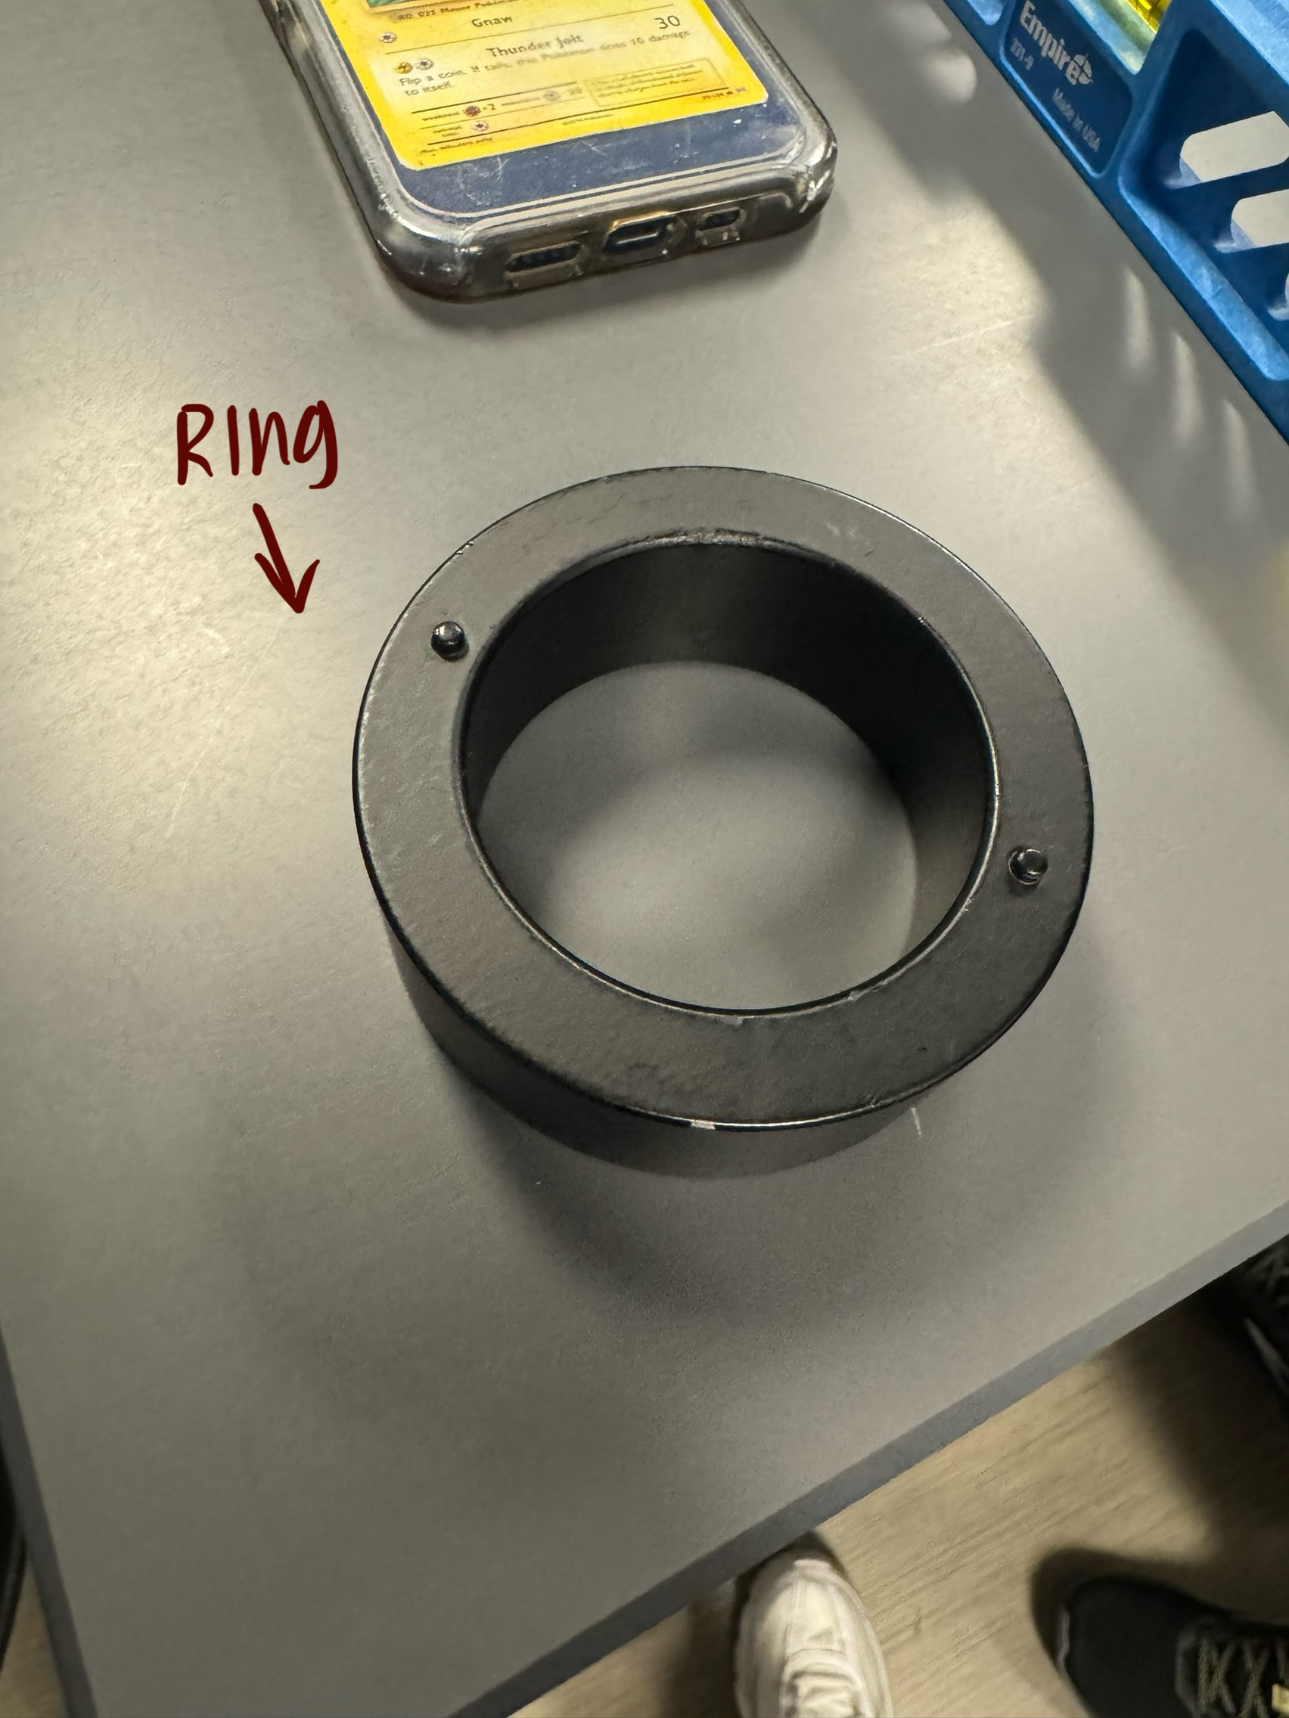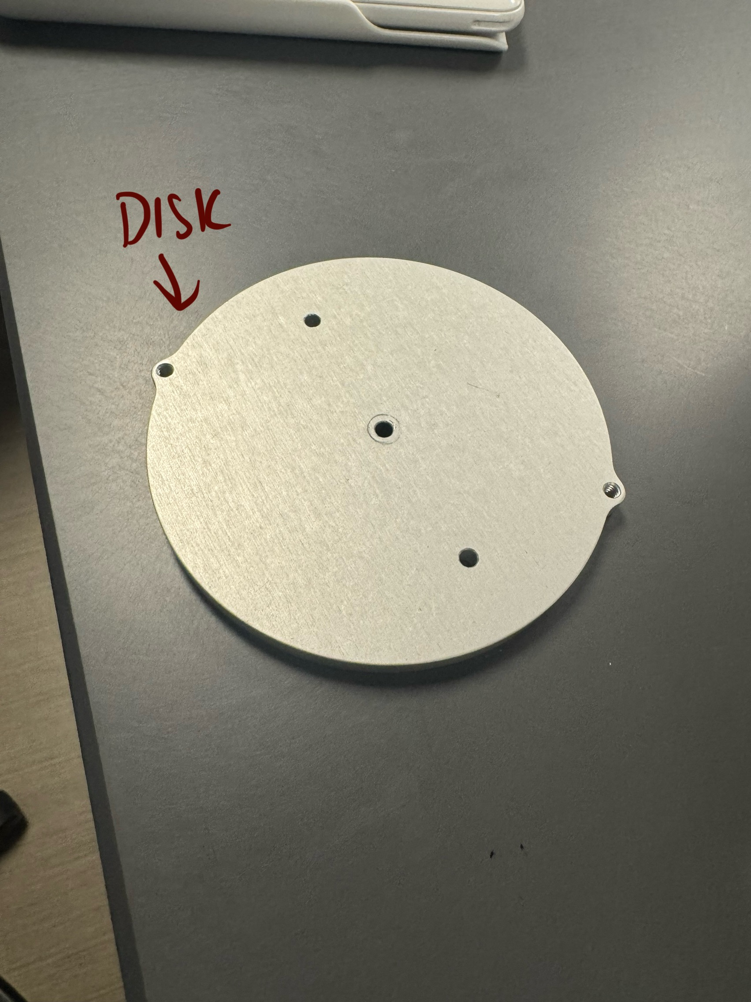

THEORY AND EQUATIONS:
Angular momentum: $L_{i} = L_{f}$ or $I_{i}ω_{i} = I_{f}ω_{f}$
Initial rotational inertia: $I_{i} = I_{d} = \frac{1}{2}M_{d}R_{d}^{2}$
Rotational inertia of the ring: $I_{RCM} = \frac{1}{2}M_{R}(R_{1}^{2}+R_{2}^{2})$
From the parallel axis theorem, the rotational inertia of the ring: $I_{R}=\frac{1}{2}M_{R}(R_{1}^{2}+R_{2}^{2})+M_{R}D^{2}$
Distance of Ring offset: $D=\left|(X_{2}-X_{1}\right|/2$
Rotational kinetic energy: $KE=\frac{1}{2}Iω^{2}$
Percent Error: $\% error = \frac{\left|Accepted value - Computed value\right|}{Accepted value }x100(\%)$

PROCEDURE:
17.4 Equipment Setup
- Use the large rod base and the 45 cm rod to support the Rotary Motion Sensor as shown in Figure 1. Plug the sensor into the interface.
- Measure the mass and radii for the disk and ring.
- Attach the disk to the clear three-step pulley on the Rotary Motion Sensor using the thumb-screw.
- Place a level on the disk and level the system using the adjustable feet on the Base.
- In PASCO Capstone, set the sample rate for the Rotary Motion Sensor to 20 Hz. Create a graph of Angular Velocity vs. Time.
17.5 Experiment
- Hold the ring with the pins up, so the ring is centered on the disk and 2 to 3 mm above it. Dropping from too high causes a large vertical force on the bearing which produces a spike in the frictional drag and results in a torque which decreases the angular momentum. However, it is also critical that all fingers are clear of the ring when it strikes the spinning disk.
- Spin the disk to give it a positive speed of about 30-40 rad/sec. Start collecting data and after about two seconds, drop the ring onto the spinning disk. Continue to collect data for a few seconds more. Fig 4 shows a screenshot of angular momentum versus time from a few seconds before to a few seconds after dropping the ring.
- It is difficult to end up with the ring centered on the disk. Let the disc stop rotating. Measure the minimum distance between the ring and the edge of the disk. Measure the maximum distance directly on the opposite side. The distance D that the ring is off-center is half of the difference between these two Measurements.
- Use the Coordinates tool to measure the rotational speed of the last data point just before the collision, and the first data point just after the collision. These are the initial and final angular velocities, ωi and ωf.

DATA AND OBSERVATION:
Before setting up the device, the disk's mass and diameter were first measured. Next was measuring the mass of the ring and measuring its inner and outer diameter. Once all the measurements were taken, the device could finally be set up.
To minimize any human error or incorrect measurements many practice spins were performed to also make sure the computer was reading the runs correctly. After the practice runs the group was testing the wheel to see how much power was needed to get the wheel to spin at 30 rads per second.
After many trials and errors were performed, it was noted that the metal disk wasn't evenly laid. What made the group aware of this imbalance was the graph sensory reading. After the 30 rad/s was reached and the speed would start to slow down, the graph would read the motion as if it was vibrating; it wasn't an even line. After adjusting the rotary motion sensor a couple times, to check if the disk was finally laying evenly, a level measuring instrument was used.
Once the group was finally ready to perform the actual trials one person was given the task to spin the disk really fast to reach the 30 rad/s. If the speed reached above 30 rad/s, then the group would wait till it went down to the right measurement. Once the desired speed was reached, the metal ring would be dropped onto the disk and was repeated a total of 3 times.

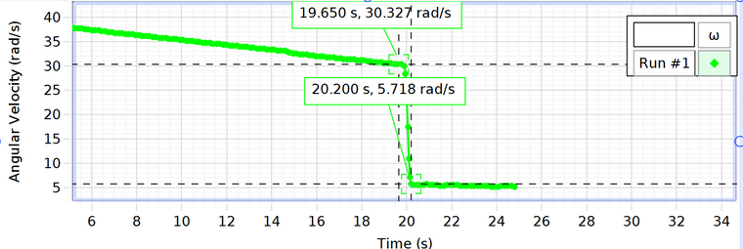
Run 1 Graph
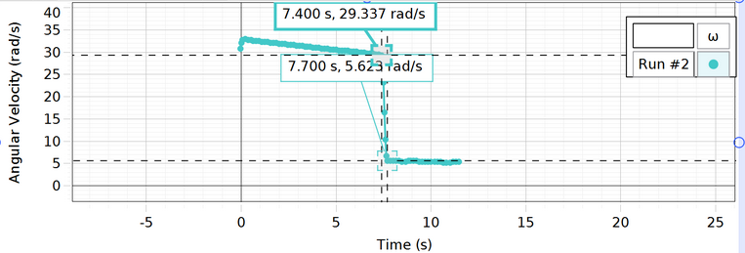
Run 2 Graph

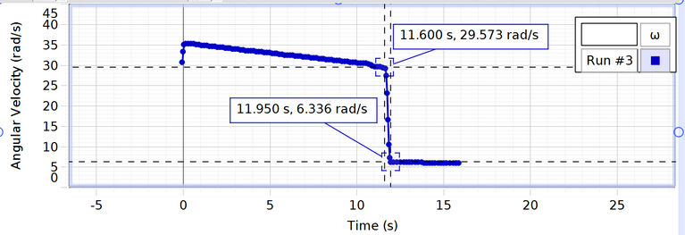
Run 3 Graph
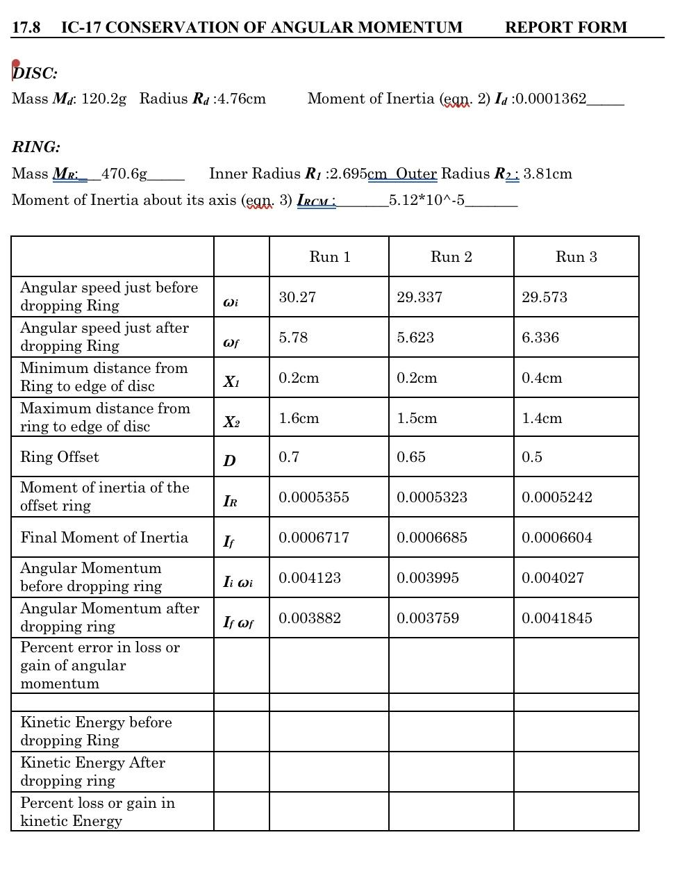

CALCULATIONS:

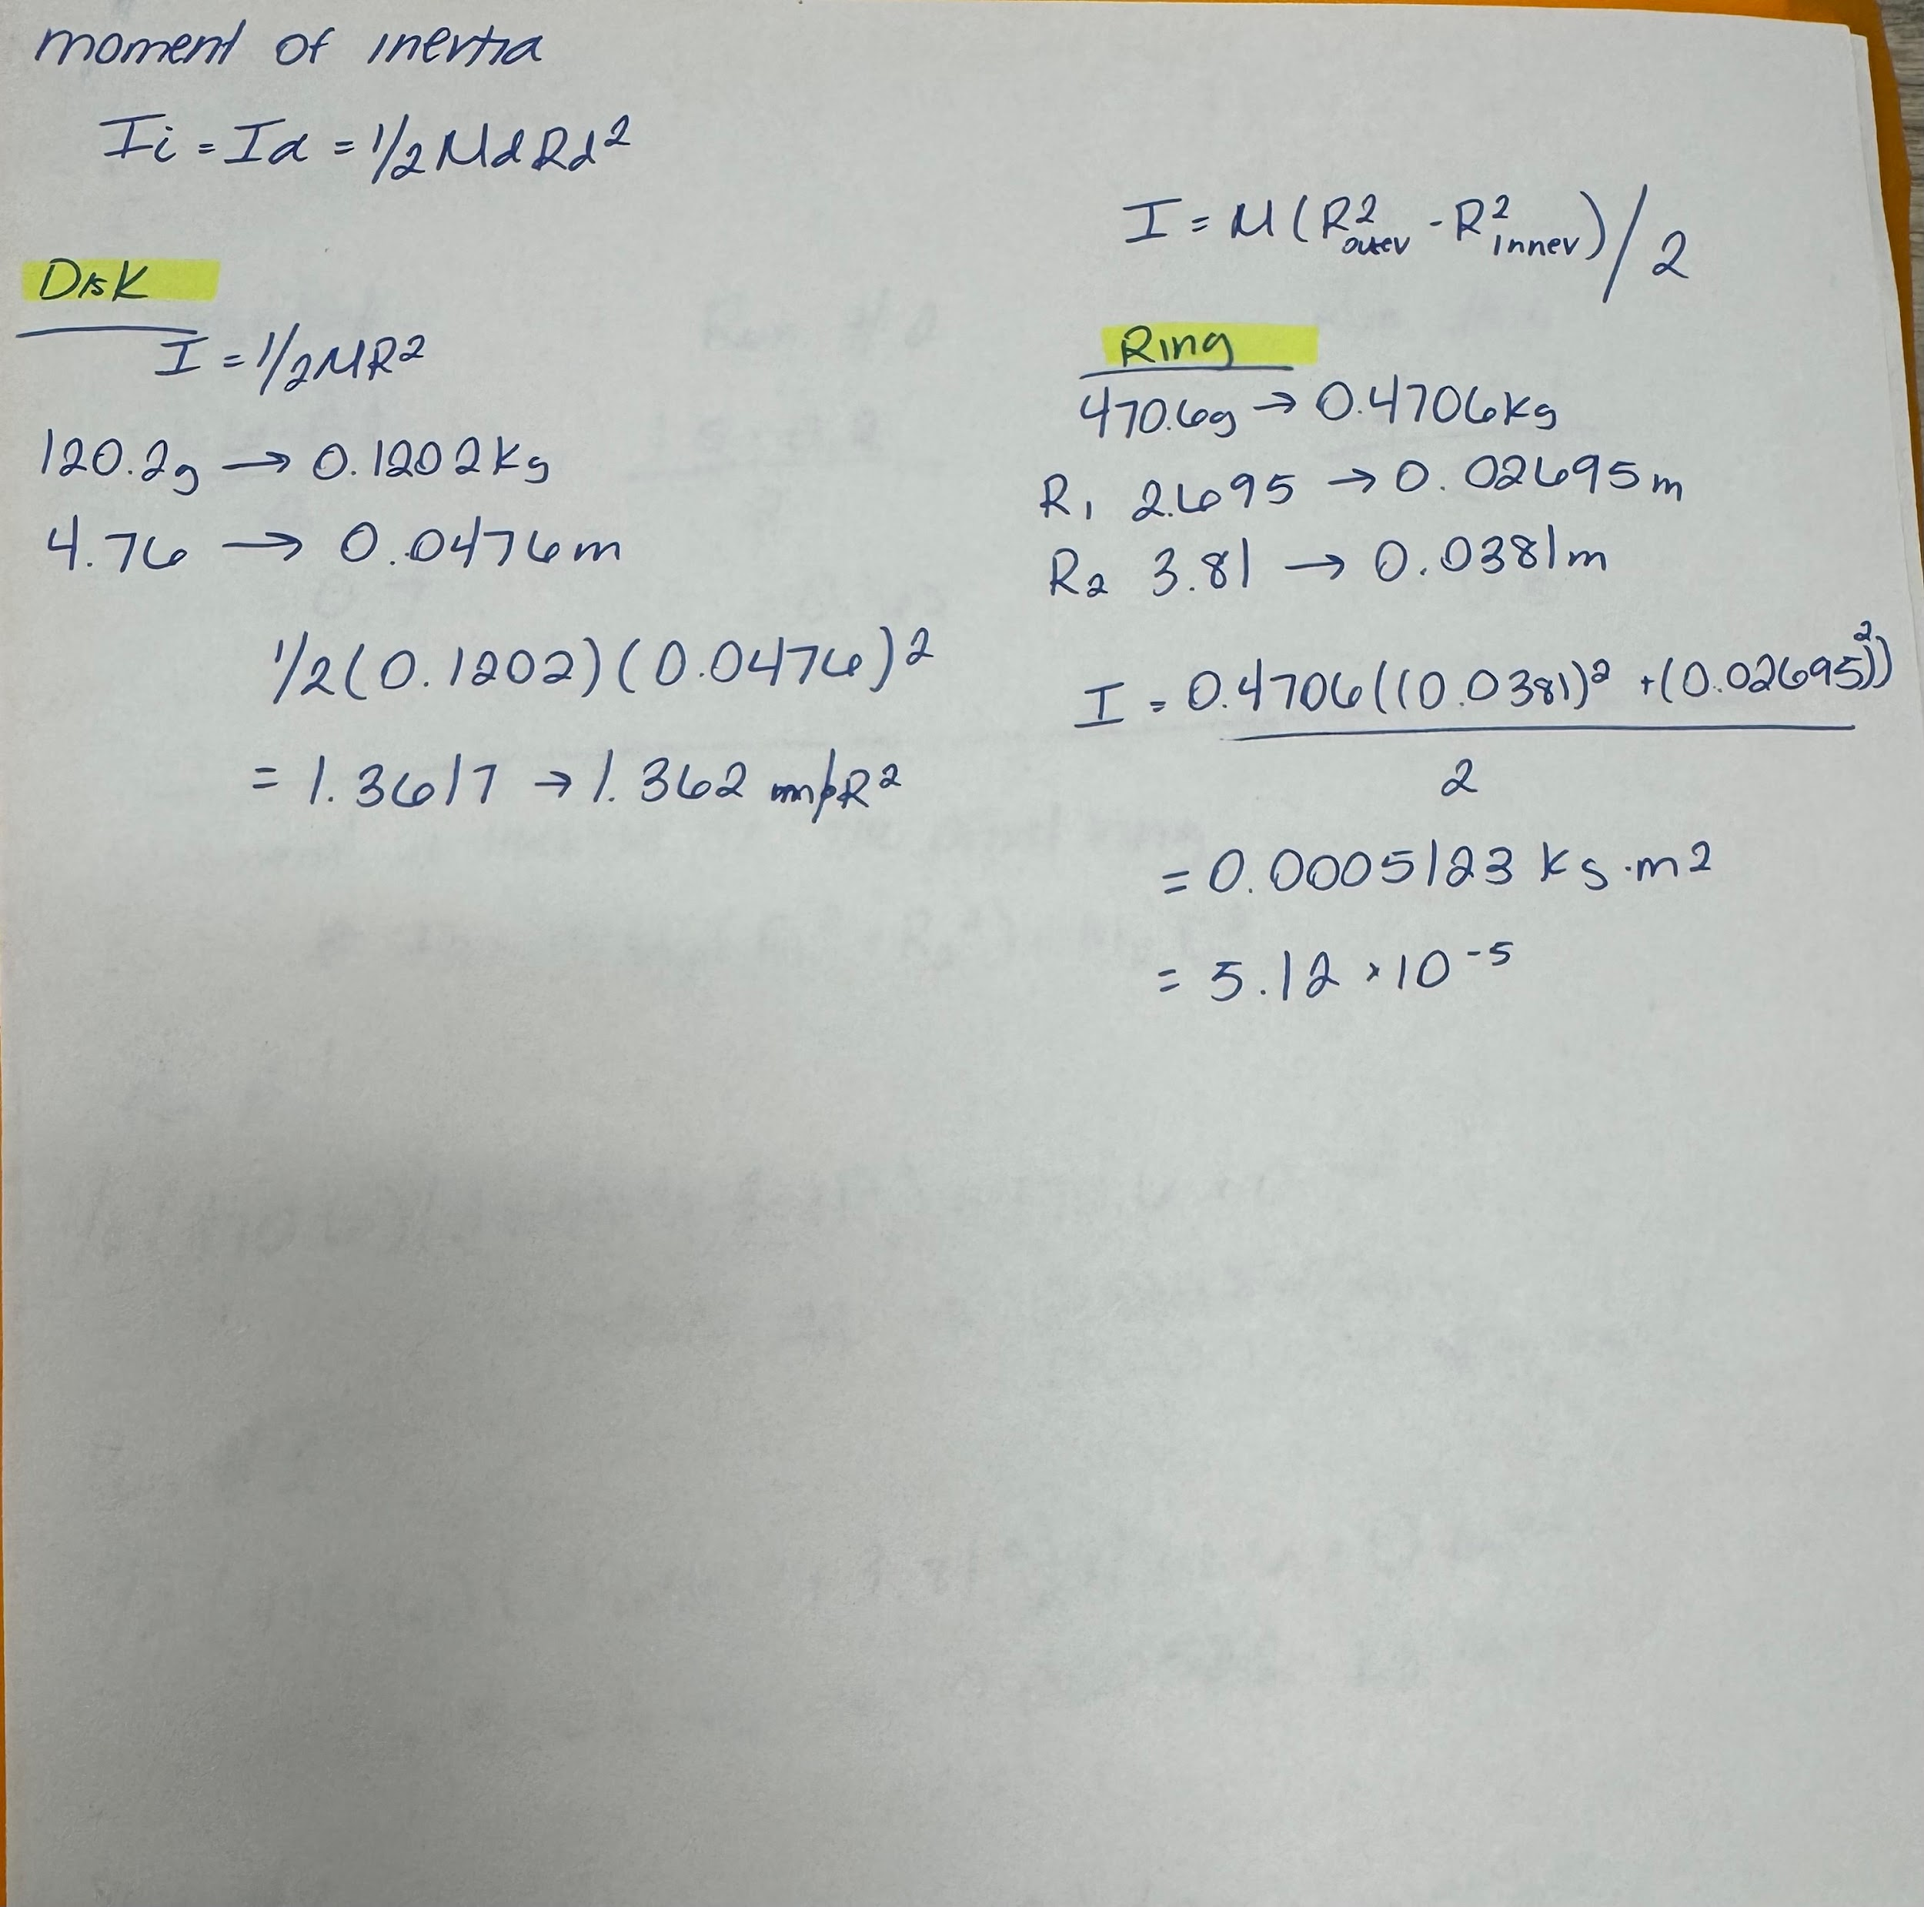
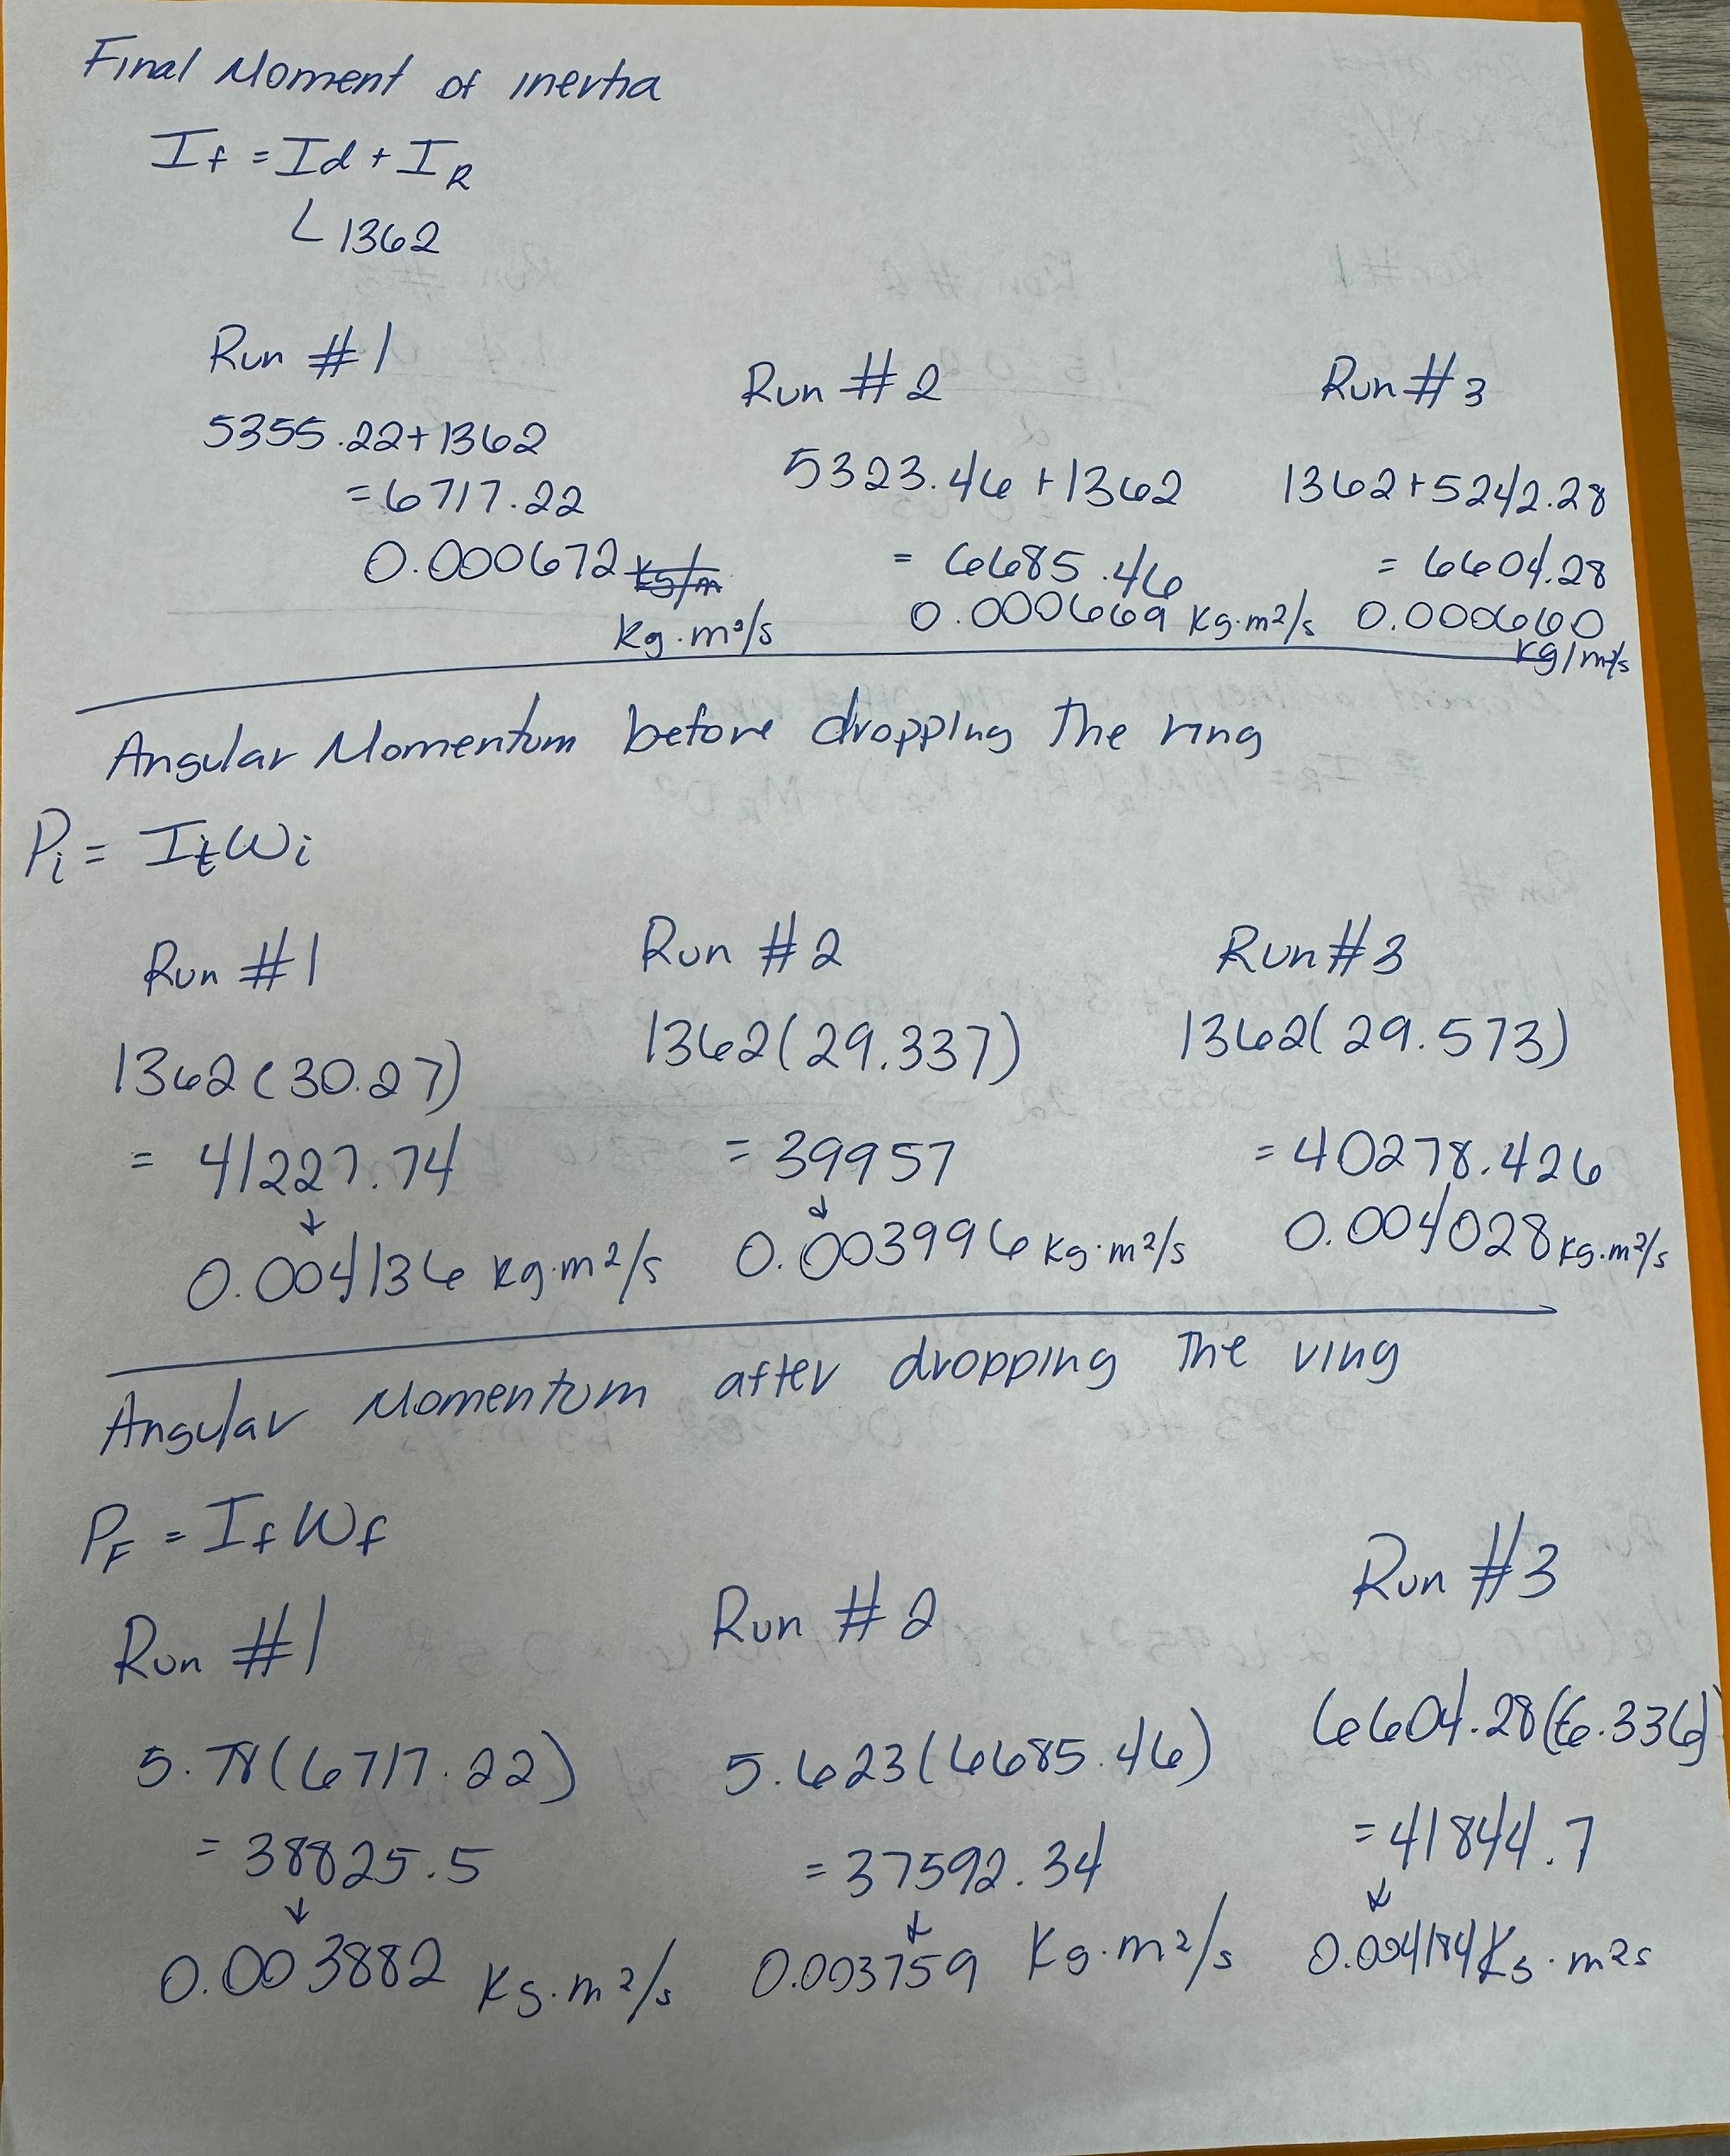
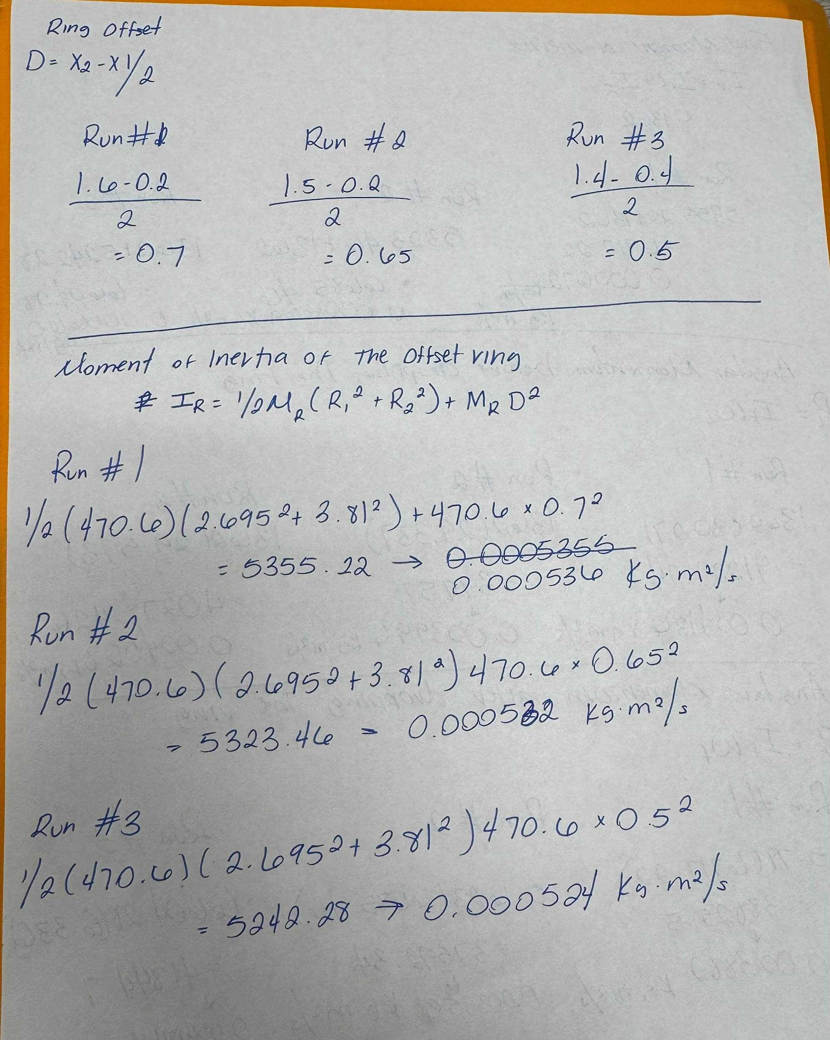

RESULTS:
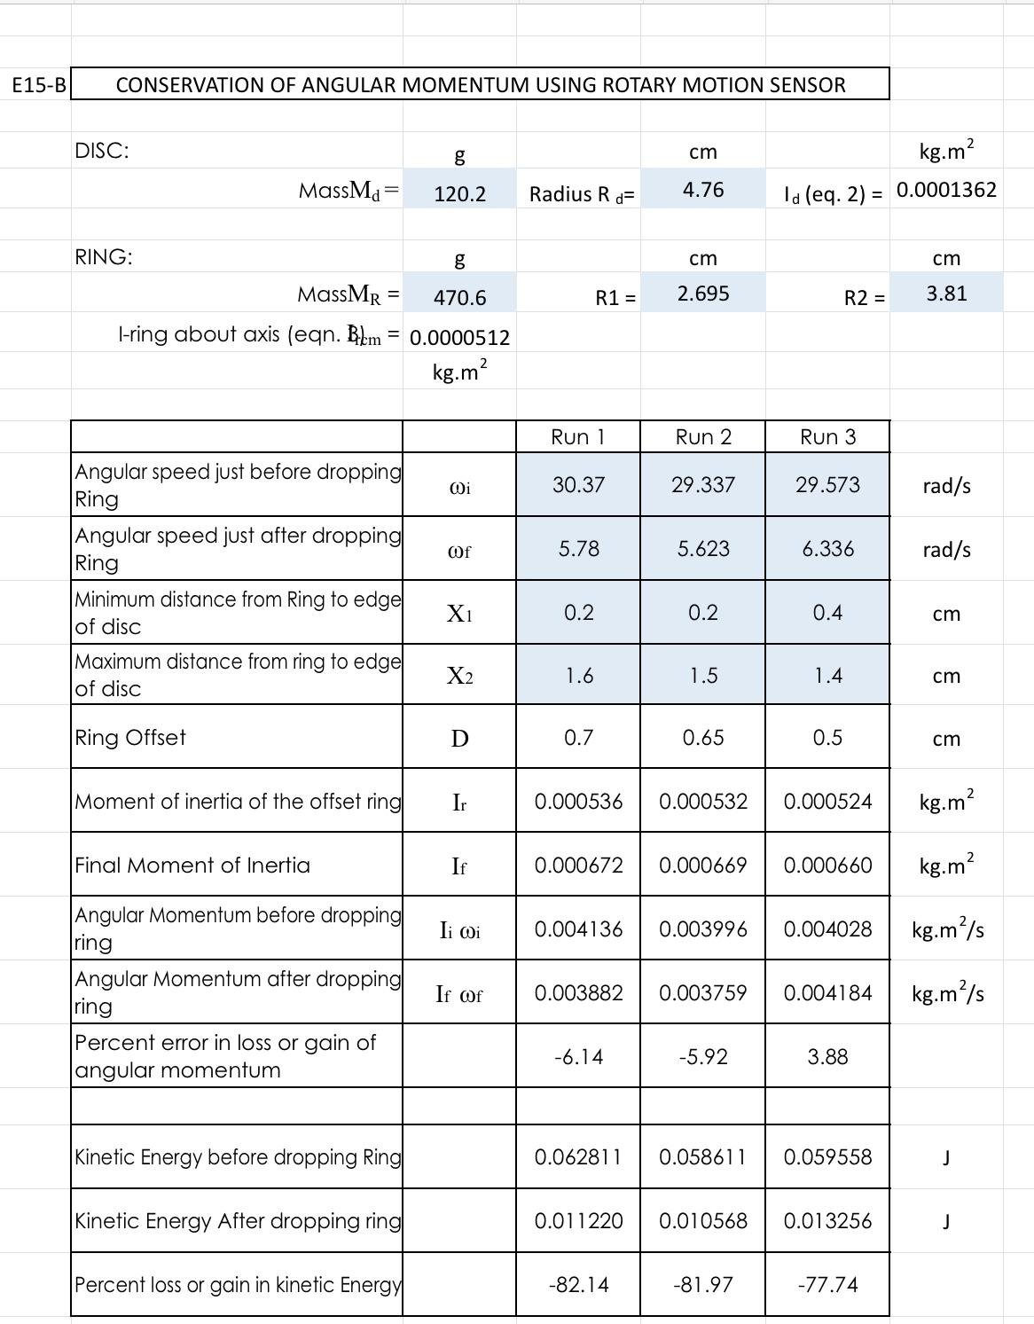

SOURCES OF ERROR:
- The dropping of the ring upon the disk was supposed to be in the absolute center of the disk. In practice however, the ring never landed in the dead center and was usually heavily skewed off to one side during rotation.
- The timing of the drop was done by eye, each one was supposed to be dropped at above thirty radians per second. As the photos of some of the runs show, several of the runs were off mark from the preferred radians per second, dipping below towards twenty-nine radians per second.

DISCUSSION:
This experiment used a spinning disk and a non-rotating ring to test the idea that angular momentum stays the same. The law of conservation of angular momentum says that a system's total angular momentum should stay the same if there is no outside force. When this happened, a stationary ring was dropped onto a spinning disk, and a rotary motion sensor was used to measure their angular speeds before and after the contact.
The mistake in angular momentum conservation was low, with values of 6.14 percent, 5.92 percent, and 3.88 percent across three runs. This shows that angular momentum was almost always the same, which proves the theory. Minor variations happen because of air resistance, friction, and the ring not being perfectly aligned on the disk. Some torque may have been added if the ring was dropped from too high or didn't land evenly. This is because small outside forces or misalignments can change the outcome.
On the other hand, the spinning kinetic energy went down significantly in all three tests, by 82.14%, 81.97%, and 77.74%. This big drop proves that kinetic energy did not stay the same, which is what you would expect from this kind of inelastic contact. When the ring hits the spinning disk, it starts to spin with it. However, energy is lost as the ring changes to the disk's motion because of friction between the ring and the disk and forces inside the ring. The drop in kinetic energy is because these forces make heat and sound, which change mechanical energy into other forms.

CONCLUSIONS:
The goal of this experiment was to study the changes in rotational kinetic energy and angular momentum when two objects collide while one is spinning. This was done by using The Law of Conservation of Angular Momentum. The objective of the experiment was successfully met by following the procedure and using the provided equations to calculate the values needed. The angular momentum conservation was relatively low which proves the theory that angular momentum is always the same. When looking at the percent loss of kinetic energy, the percentages are extremely high, which shows that kinetic energy does not stay the same due to the contact being inelastic.

